

**Structural Equation Modelling**

The influence of importance of religious values and tradition among people on their perception of the justifiability of social taboos

Adhithya Unni Narayanan (r0776057)

May 2021

**Table of Contents**

1. **Introduction**
2. **Framing of the research problem**
3. **Description of the Dataset**
4. **Data Exploration**
5. **Modelling**
   1. **Model Structure**
   2. **Equations of the model**
   3. **Direct and Indirect effects on η2 in the model**
   4. **Multigroup Analysis**
6. **Results**
   1. **Results of the Mediation Model**
      1. **Analysis of the factor loadings**
      2. **Analysis of the residual matrix and residual variances**
      3. **Analysis of the global fit**
      4. **Analysis of the Modification Indices**
      5. **Direct and Indirect Effects on the latent factor Justifiability of social taboos**
   2. **Results of Measurement Invariance**
      1. **Configural Invariance**
      2. **Metric Invariance**
      3. **Conclusion for the Measurement Invariance**
7. **Conclusion**
8. **Appendix A**
9. **Appendix B**
10. **References**
11. **Introduction:**

Religion is one aspect of life that is familiar to almost all the humans. Origin of religion dates back to centuries. According to Thoresen (1998), religious involvement is referred as “an organized system of [religious] beliefs, practices, rituals, and symbols”. It is said to impart values like respect, love, compassion, empathy, harmony and discipline to the society and hence is very well intertwined to the core of societal values. On the contrary, religion and culture are also proven to inhibit a lot of its followers to open up their minds to the progressing human rights values and vision. Although there are many human right advocacies that try to bring distinction between culture and religion, it was seen that these two are not so distinct with cultural practices being “religionized” and religious ideas becoming a part of the culture (Mariam Rawan Abdulla, 2018). Thus, being an integral part of the societal structure, it is always assumed that religion and its values has a major role in the existence of social norms and taboos. Chaim Freshtman et al refers social norms and taboos as a list of behavioural guidelines. The way a society dress, eat, behave, even the sex life, are all governed by these social norms and taboos.

Although social taboos differ depending on various religious values and social structure, there are many which are mostly common to prevalent religions in the world. According to the World Population Review, the three major religions in the world include Christianity (2.38 billion followers), Islam (1.91 billion followers) and Hinduism (1.16 billion followers) and according to these religions, aspects like homosexuality, prostitution, sex before marriage, abortion, divorce, euthanasia are clearly forbidden and thus is frowned upon if practiced.

The social taboos mentioned above when considered rationally should be the decisions personal to the individual and ideally there shouldn’t be any prejudices bestowed upon them. But the strong roots of religious views and traditions are constantly blamed to have an effect on the society permanently looking down on an individual’s freedom to embrace these social taboos. In this paper, we will be analysing the association of religious values and tradition on the justifiability of certain social taboos.

1. **Framing the research problem**:

People over the years have protested against the religious fundamentalism and the way it encouraged generations to perceive anything that is not defined by their rulebook as wrong or immoral to practice. As a result, it can be easily assumed that people having strong religious values will be strongly against the justifiability of social taboos such as homosexuality, sex before marriage, prostitution, abortion and divorce.

We have discussed before about the religion and traditions being literally distinct and practically closely associated. But here, to give the benefit of doubt, we take the importance of tradition to people separately to see if the above claim on tradition being closely related to the religious values are true and if so, how well are they associated. But mainly, will be seeing if they influence the justifiability of social taboos given above. Another question we will be looking for will be if the difference in the countries have any impact in the attitude of respondents who consider religious values and tradition important towards the Justifiability of social taboos. This is because these two countries follow two different religions and according to the World Population Review data, 68% of the people in Australia doesn’t give much importance to religion and 92% of the people in Pakistan deem religion as an important aspect in their life. Also, these two countries predominantly follow two different religions Christianity and Islam.

So, to conclude, we will be making structural equation model assuming that the variable ‘Importance of Tradition’ contributes to the latent factor ‘Importance of Religion’ and both of them in turn is associated to the ‘Justifiability of social taboos’ which is a latent factor based on the respondents from Australia and Pakistan combined. We also try to see if the same model applied separately to two different countries derive any significant results.

1. **Description of the dataset:**

The dataset from the World Value Survey (WVS) wave 6 is used for the analysis. WVS is an international research program devoted to the scientific and academic study of social, political, economic, religious and cultural values of people in the world. The dataset taken from WVS contains responses of 2035 respondents of 2 countries Australia and Pakistan on 9 variables. The description of the variables is given below:

|  |  |
| --- | --- |
| I_tradition | Importance of tradition to the respondent (scale 1-6, 1 being least important and 6 being very important) |
| R_attend_religious_services | How often do the respondent attend religious services (scale 1-7, 1 = never and 7 = more than once a week) |
| R_pray | How often does the respondent pray (scale 1-8, 1= never and 8 = more than once a week) |
| R_importance_god | How important is god in respondent’s life (scale 1-10, 1 = not at all important and 10 = very important) |
| J_homosexuality | Justifiability of respondent on homosexuality (scale 1-10, 1 = never justifiable and 10 = always justifiable) |
| J_prostitution | Justifiability of respondent on prostitution (scale 1-10, 1 = never justifiable and 10 = always justifiable) |
| J_abortion | Justifiability of respondent on abortion (scale 1-10, 1 = never justifiable and 10 = always justifiable) |
| J_divorce | Justifiability of respondent on divorce (scale 1-10, 1 = never justifiable and 10 = always justifiable) |
| J_sex_before_marriage | Justifiability of respondent on sex before marriage (scale 1-10, 1 = never justifiable and 10 = always justifiable) |

Only respondents with complete data records for the 32 items were included in the data set.

1. **Data Exploration:**

Basic exploration of the data to be analysed is carried out in this section. The exploratory analysis shows the count, mean, standard deviation, median, minimum, maximum, skewness and kurtosis of the variables (Table 1: Appendix A). The covariance matrices between the variables are also analysed. The correlation between all the variables within groups. The correlation plot (Figure 1: Appendix A) shows high correlation between the variables that indicates justifiability of social taboos (J_homosexuality, J_prostitution, J_abortion, J_divorce and J_sex_before_marriage). Similar is the case for Pakistan (Figure 2: Appendix A). A good correlation can also be seen within the variables that contribute to importance of religious values (R_attend_religious_services, R_importance_god, R_pray) among responses from Australia. But similar trend is not visible for the case in Pakistan. Finally, correlation matrix for the data as a whole (2 countries combined) is also considered (Figure 3: Appendix A). Here we can see strong correlations between all the variables.

1. **Modelling:**

In this part, we will be discussing in detail about the modelling. We will be analysing the effect of Importance of Tradition and Religious Values on the Justifiability of social taboos. A Mediation model is used for this purpose. We plan to conduct a multigroup analysis but this depends on the measurement equivalence.

* 1. **Model Structure:**

**R_attend_religious_services**

λ6

λ7

γ11

**R_pray**

λ8

**R_impotance_god**

**I_tradition(ξ)**

β21

γ12

λ1

λ3

λ4

λ5

λ2

**J_homosexuality**

**J_prostitution**

**J_sex_before_marriage**

**J_abortion**

**J_divorce**

Figure 1: Model for estimation

Given above is the picturisation of the model we are trying to estimate. Here, we have one exogenous variable and ten endogenous variables. The variable ‘Importance of religious values’ is taken as a latent factor and the indicator variables that feed into this latent variable are R_attend_religious_activities, R_pray, R_importance_god. The ‘Justifiability of Social taboos’ is also taken as a latent factor and the variables that contributes to it are J_homosexuality, J_prostitution, J_abortion, J_divorce and J_sex_before_marriage. 2 measurement models and one structural model incorporates this MIMIC model. We are also considering the direct and indirect effect of the exogenous variable ‘I_tradition’ and the latent factor ‘Importance of religious values’ on the dependent variable ‘Justifiability of social taboos’. The factor loadings in the measurement model are denoted by λ, factor loadings of exogenous variable (ξ) on the latent factors (η) are denoted by γ and the factor loading of the latent factor η2 on η1 is denoted by β.

So, in this model, we will be checking the hypothesis that the model implied covariance matrix (Σ) of this model will be close to the observed covariance matrix (S) through various goodness of fit measures.

* 1. **Equations of the Model**

For the Measurement models, the equations are,

Justifiability of Social Taboos: Χn = ΛnΞ + Δn where n = 1, 2, 3, 4, 5.

Importance of religious values: Υn = ΛnΞ + Δn where n = 1, 2, 3

For the structural Model, η = Βη + Γξ + ζ

The system of equations for both the models are given in Appendix A.

* 1. **Direct and Indirect effects on η2** **in the model**

γ11

β21

**I_tradition(ξ)**

γ12

Figure 2: Path model

The direct and indirect effects of the latent variable η1 and exogenous variable ξ on the dependent latent variable η2 are also considered. The Figure above shows the path model that is considered for the effects. Here, we can see that the total effects of exogenous variable on the dependent variable will be γ21 + γ11 * β21 and the latent factor η1 on the dependent variable will be β21. The effect of I_tradition on I_religious_values is given by γ11.

* 1. **Multigroup Analysis**

The rationale behind a multigroup modelling is discussed above and the idea is to categorise the dataset into two groups based on countries Australia and Pakistan. This type of modelling is very popular in comparative research. The two groups will have same model described above applied. But before the comparison part, it is important to see if the groups are comparable or not. In other words, we have to test for the measurement equivalence for the groups. Measurement equivalence have 5 types to it. They are Configural, Metric, Scalar, Strict and Structural invariance. Here, we will be looking for configural and metric equivalence because our intention is to see if the model have the same construct across the groups. Multigroup analysis makes sense only if we have configural and metric invariance in our case.

1. **Results:**

In this section, we will be discussing the results of the analysis. The first part of this section contains results for the Mediation model and in the second part, the measurement equivalence of the model is discussed. The model is analysed using Lavaan in R.

* 1. **Results of the Mediation model**

First of all, we have to see if the model fits the data well and then the effects will be analysed. The equations used for the model in the program is given in the Appendix A.

6.1.1 Analysis of the factor loadings

|  |  |  |  |
| --- | --- | --- | --- |
|  | Estimate | S.E | p-value |
| J_social_taboos by: |  |  |  |
| J_homosexuality | 0.898 | 0.100 | 0.000 |
| J_prostitution | 0.812 | 0.086 | 0.000 |
| J_abortion | 0.896 | 0.076 | 0.000 |
| J_divorce | 0.842 | 0.118 | 0.000 |
| J_sex_before_marriage | 0.934 | 0.084 | 0.000 |
| I_religious_values by: |  |  |  |
| R_attend_religious_services | 0.661 | 0.080 | 0.000 |
| R_pray | 0.873 | 0.093 | 0.000 |
| R_importance_god | 0.904 | 0.130 | 0.000 |
| I_tradition on J_social_taboos | -0.099 | 0.040 | 0.000 |
| I_tradition on I_religious_values | 0.495 | 0.022 | 0.000 |
| I_religious_values on J_social_taboos | -0.752 | 0.067 | 0.000 |

Table 1: Standardized factor loadings

Factor loadings are essential when it comes to assessing the measurement quality. Strong factor loading indicates the measurement quality is good. Table 1 shows the standardized factor loadings of the indicator variables by the latent variables J_social_taboos and I_religious_values. Looking into the first 5 factor loadings, we can say that the manifest variables load highly on the latent variable Justification of social taboos. It means that the association of manifest variables J_homosexuality, J_prostitution, J_abortion, J_divorce and J_sex_before_marriage to the latent variable Justifiability of social taboos is verry strong or in other words, we can say that when the latent Justifiability of social taboos is increased by one unit, the justifiability of homosexuality, prostitution, abortion, divorce and sex before marriage increases by 0.898, 0.812, 0.896, 0.842 and 0.934 respectively. This is a very good sign as it indicates that the latent variable explains the indicators very well. Similarly, the factor loadings by the latent variable Importance to religious values are also very good. The three indicators have high loadings on the latent factor.

The standardized loadings of the exogenous variable I_tradition on the latent variables I_religious_values and J_social taboos are also given in the table. This shows the effect of Importance of tradition for the respondents on the Importance of religious values and Justifiability of social taboos. It can be seen that the exogenous variable has very low negative loading on the Justifiability of social taboos. It means that the variable has a very minimal negative effect on the latent factor. On the contrary, the variable has a decent positive loading on the importance of religious values. This might be due to the fact that traditions are predominantly influenced by religions. A high negative factor loading of the I_religious_values on J_social_taboos can be noted in the table. This reinstates the theory that people who consider religious values important has a negative attitude when it comes to the justifiability of social taboos. In general, it can also be seen that the factor loadings are all significant.

6.1.2 Analysis of the residual matrix and residual variances

This analysis is conducted on the hypothesis that the implied covariance matrix (Σ) is similar to the observed covariance matrix. If this is true, the difference between the observed covariance matrix (S) and implied covariance matrix should be as small as possible. This can be inferred from a residual matrix.

|  |  |  |  |  |  |  |  |  |  |
| --- | --- | --- | --- | --- | --- | --- | --- | --- | --- |
|  | J_homo | J_prs | J_abr | J_dvc | J_sx__ | R_att__ | R_pra | R_imp_ | I_tra |
| J_ho | 0.000 |  |  |  |  |  |  |  |  |
| J_prs | 0.109 | 0.000 |  |  |  |  |  |  |  |
| J_abr | -0.095 | 0.263 | 0.000 |  |  |  |  |  |  |
| J_dvc | -0.085 | -0.122 | 0.147 | 0.000 |  |  |  |  |  |
| J_sx | 0.123 | -0.108 | -0.164 | 0.039 | 0.000 |  |  |  |  |
| R_att | 0.158 | 0.210 | -0.007 | -0.017 | -0.049 | 0.000 |  |  |  |
| R_pra | 0.393 | 0.423 | 0.107 | 0.043 | -0.057 | 0.238 | 0.000 |  |  |
| R_imp | 0.157 | 0.295 | -0.394 | 0.011 | -0.437 | -0.217 | 0.002 | 0.000 |  |
| I_tra | -0.118 | -0.009 | -0.016 | 0.252 | -0.017 | 0.096 | -0.146 | 0.093 | 0.000 |

Table 2: Residual matrix showing the difference between S and Σ

From the residual matrix, it can be noted that the residuals are not very high. This means that the estimated covariance matrix is somewhat similar to the observed. There are only 2 residuals that go past 0.40. The standardized residual variances of the indicator variables are also taken into account as this shows the amount of measurement errors in the indicators. The residuals are very small for almost all indicators. Although the residual variance of R_attend_religious_services is more in comparison to all other residual variances (Table 2: Appendix A). This is also reflected in the factor loading of that variable. It means that there may exist any other factors that could explain the particular variable apart from the latent factor that we considered.

6.1.3 Analysis of the Global Fit

In order to analyse the global fit of the model, we look into the goodness of fit measures. Here, the chi-square goodness of fit measure, Standardized Mean Square Residual (SRMR), Comparative Fit Index (CFI), Tucker-Lewis Index (TLI) and Root Mean Square Error Approximation (RMSEA) are considered and the overall fit is decided on the basis of these values for our model.

|  |  |  |  |  |  |  |
| --- | --- | --- | --- | --- | --- | --- |
| Chi-sq | df | p-value | SRMR | CFI | TLI | RMSEA |
| 291.902 | 25 | 0.000 | 0.021 | 0.982 | 0.974 | 0.072 |

Table 3: Fit measures of the model

From Table 3, it can be seen that the Chi-square value is very high for the degrees of freedom we have. The test is done under the hypothesis H0 : S =Σ and it works under the assumption that the data follows multivariate normality. Thus, this test is very sensitive when datasets with large sample size are analysed. Here, we have to reject the hypothesis since p-value equals to 0 but since it is very sensitive, we will emphasise on the other fit measures.

The SRMR value shows the discrepancy between the implied and observed covariances. Going by the rule of thumb, SRMR < 0.08 is acceptable. The measure yields a low value only if the residuals are small which we have discussed in section 6.1.2. The SRMR value for our model is thus satisfiable.

Now we are considering the Incremental fit indices CFI and TLI. In both these indices, we take our model as a target model and compare it with a baseline model which has the worst possible fit. Both the values indicate percentage of improvement of fit from the baseline model. The CFI value for this model is 0.982 which means that our model is 98.2% better than the worst possible model. Moving on to TLI, it is similar to that of CFI but it gives more weight to the degrees of freedom and as a result rewards more parsimonious models and punishes the model that are complex. According to the rule of thumb, TLI value > 0.95 is acceptable and here our model satisfies the condition thus indicating that the model is a good fit and parsimonious at the same time.

RMSEA calculation does not consider the Chi-square value to be 0 (if this value has to be 0, the implied and observed covariance matrices should be equal) and thus gives a space for an error of approximation. RMSEA value < 0.05 is considered to be acceptable but our model does not satisfy the condition.

Considering the overall global fit indices, the residual matrix and the strength of the factor loadings, we can say the model has decent acceptable fit measures and fits the data pretty well but before concluding, we have to check if there is any scope for modification.

6.1.4 Modification Indices

The model we have created has certain constraints. The modification indices show us how much of a change we can bring to the Chi-square value if more constraints are introduced.

|  |  |  |  |
| --- | --- | --- | --- |
|  | M.I | E.P.C | Std E.P.C |
| R_attend_religious_services with R_pray | 52.847 | 0.489 | 0.231 |
| R_attend_religious_services with R_importance_god | 52.045 | -0.596 | -0.265 |
| J_abortion with J_sex_before_marriage | 46.420 | -0.477 | -0.258 |
| J_prostitution with J_abortion | 44.466 | 0.399 | 0.182 |
| I_religious values by J_prostitution | 33.861 | 0.319 | 0.160 |

Table 4: MI sorted in descending order

Table 4 shows the first 5 values when the modification index of the model is sorted in descending order. The M.I column of the table depicts how much reduction will be there in the chi-square value if the corresponding constraint is added. Here, it can be seen that adding a covariance between R_attend_religious_services and R_pray can reduce the chi-square value by 52.847. The Standard Expected Parameter Change indicates the change in the parameter if this particular constraint is added. So, if we are considering to modify the model to improve its fit, this can be measured.

In our case, we can consider adding the first 4 constraints. When tried adding them, there wasn’t much change in the factor loadings but the RMSEA value managed to come down to 0.055 which is close to the cut off value, CFI and TLI value has improved and the chi-square value has reduced as expected. But since this modification made the model a bit more complex to handle, it is not considered. Details about the modified model in Appendix A.

6.1.5 Direct and Indirect Effects on the latent factor Justifiability of social taboos

|  |  |  |  |
| --- | --- | --- | --- |
|  | Estimate | Std. Estimate | p-value |
| a | 0.455 | 0.495 | 0.000 |
| b | -1.807 | -0.752 | 0.000 |
| c | -0.218 | -0.099 | 0.000 |
| ab | -0.821 | -0.372 | 0.000 |
| total | -1.039 | -0.471 | 0.000 |

Table 5: Direct and Indirect effects of variables

General discussion about the effects in the path model, it be seen that the effect of exogenous variable Importance in tradition (**a** in Table 5) on the latent factor Importance of religious values is significant and positive. But this exogenous variable does not seem to have a strong direct effect (**c** in Table 5) on the latent factor Justifiability of social taboos nevertheless it has to considered that the effect it has is negative which tells us that the respondents who consider traditions as important does not justify the social taboos very much. It also has to be noted that this effect is significant according to the p-value. However, the direct effect (**b** in Table 5) of the latent factor Importance of religious values on the dependent variable Justifiability of social taboos is strong and negative and this helps us to show that the people who considers the religious values as important has a strong negative attitude towards the social taboos.

Specifying effects on the latent variable Justifiability of Social Taboos, the total effect of the other variables on this dependent variable can be decomposed into direct and indirect effects. The direct effect on this dependent variable by the other two variables are already discussed. Considering the other one, this indirect effect is through the path:

I_tradition I_religious_values J_social_taboos

Here, the effects get multiplied (**ab** in Table 5) and from the Table 5, we can see that there is a significant indirect effect on the dependent variable. From this, we can say that for the respondents who feels tradition and religious values are important, their attitude towards the social taboos is way negative. From the total effect also, we can show that there is a negative attitude towards social taboos among people who deem tradition and religious values important in their life.

* 1. **Results of Measurement Invariance**

In this section, we will have the configural and metric equivalence. Configural equivalence means we have same configuration of factors across the groups. It assumes we have same constructs across the groups i.e., no construct bias is present. But this equivalence doesn’t say anything about the score comparability. Metric equivalence means that we have exactly same factor loadings across the groups and thus guarantees comparability.

* + 1. Configural Invariance

The sample size per group is 958 and 1077 for Australia and Pakistan respectively. It is important to look at the sample size because it influences the power and the test statistic of chi-square depend on the sample size. Looking into the chi-square test statistic of each group, we can see that Australia has a chi-square value of 166.519 and that of Pakistan is 279.324. This difference might be due to the difference in the sample size between the countries but if we have had a balanced sample size, we could have concluded that the misfit of the model is higher in Pakistan.

|  |  |  |  |  |  |  |
| --- | --- | --- | --- | --- | --- | --- |
| Chi-sq | df | p-value | SRMR | CFI | TLI | RMSEA |
| 445.843 | 53 | 0.000 | 0.064 | 0.944 | 0.924 | 0.085 |

Table 6: Fit measures for the configural model

From Table 6, it can be seen that none of the fit measures indicate that the model is a good fit according to the rule of thumb. This fit has fairly high factor loadings for both the groups.

* + 1. Metric Invariance

Metric invariance essentially means one unit of increase in the latent factor has the same effect on both the groups. There is a noticeable difference in the chi-square values for Australia and Pakistan (274.389 and 315.666 respectively) and this difference can be an indicator that the model misfit is higher in Pakistan.

|  |  |  |  |  |  |  |
| --- | --- | --- | --- | --- | --- | --- |
| Chi-sq | df | p-value | SRMR | CFI | TLI | RMSEA |
| 590.055 | 59 | 0.000 | 0.085 | 0.924 | 0.908 | 0.094 |

Table 7: Fit measures for the metric model

Table 7 shows higher value for chi-square for the metric model and this is because as we increased the constraints. Fit measures do not show any acceptable fit.

* + 1. Conclusion for the Measurement Invariance

From the sections 6.2.1 and 6.2.3, it is clear that both the models do not allow comparison between the groups. The configural model being the baseline model itself doesn’t show any good fit measures. This means that the underlying assumption of the configural model that there is no construct bias present is wrong. The construct bias occurs when we try to compare groups which are not comparable. Here, we are trying to compare two countries Australia and Pakistan and the reason why they are not comparable can be credited to the major difference in their religion. So essentially, a multigroup model doesn’t make any sense because of the lack of comparability.

1. **Conclusion:**

The mediation model we constructed to find answers for our research questions served well in finding an answer. The model was shown to have a decent fit in terms of the factor loadings, residuals and global fit indices. Thus, the research question about the assumption about the attitude of people having strong religious and tradition views considering the social taboos as something less justifiable is proved from the direct and indirect negative effects of I_religious_values and I_tradition respectively.

We have also come across a statement that tradition (or culture) has a close association to religion. From the direct effect of I_tradition to the I_religious_values, it can be seen that this statement can be supported.

When looking into the differences of attitudes of respondents of 2 different countries towards first research question, we have not been able to compare it because of the construct bias. This construct bias might have originated from the fact that the 2 countries follow different religion and their religious practices differ tremendously. For example, Islam as a religion has more strict rules towards its followers perceiving the social taboos and Christianity on the other hand is much lenient in comparison. This also depends on the outlook of the respondents towards these social taboos.

**Appendix A:**

**Section 4: Data Exploration**

|  |  |  |  |  |  |  |  |  |
| --- | --- | --- | --- | --- | --- | --- | --- | --- |
| Variables | n | mean | sd | median | min | max | skewness | kurtosis |
| I_tradition | 2035 | 4.1901 | 1.4726 | 4 | 1 | 6 | -0.4812 | -0.7885 |
| R_attend_religious_services | 2035 | 3.4815 | 2.0473 | 4 | 1 | 7 | 0.1331 | -1.3636 |
| R_pray | 2035 | 5.3434 | 2.8241 | 6 | 1 | 8 | -0.5666 | -1.3625 |
| R_importance_god | 2035 | 7.5361 | 3.4255 | 10 | 1 | 10 | -1.0142 | 0.6384 |
| J_homosexuality | 2035 | 4.2191 | 3.6187 | 2 | 1 | 10 | 0.6031 | -1.2974 |
| J_prostitution | 2035 | 3.1361 | 2.7021 | 2 | 1 | 10 | 1.0324 | -0.1006 |
| J_abortion | 2035 | 3.6624 | 3.1314 | 2 | 1 | 10 | 0.7748 | -0.8706 |
| J_divorce | 2035 | 4.6260 | 3.3722 | 5 | 1 | 10 | 0.3150 | -1.4027 |
| J_sex_before_marriage | 2035 | 4.4560 | 3.7313 | 3 | 1 | 10 | 0.4635 | 1.5184 |

Table 1: descriptive data for the Variables

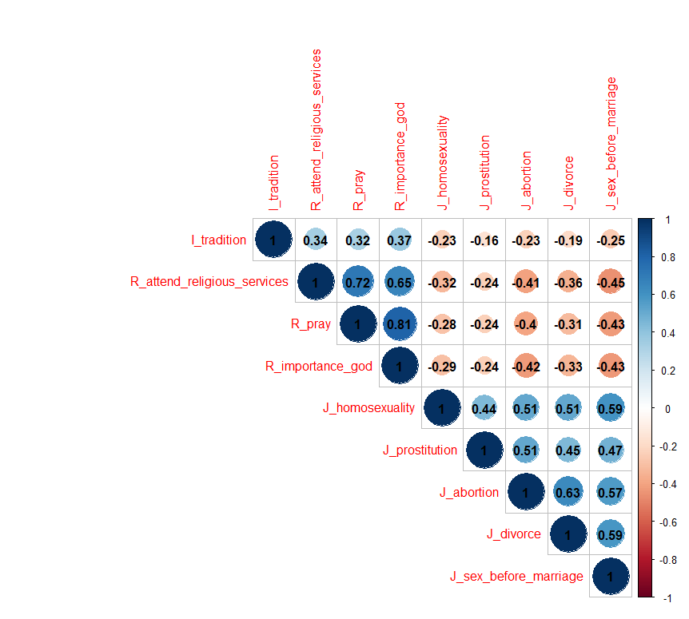

Figure 1: Correlation matrix for variables from Australia

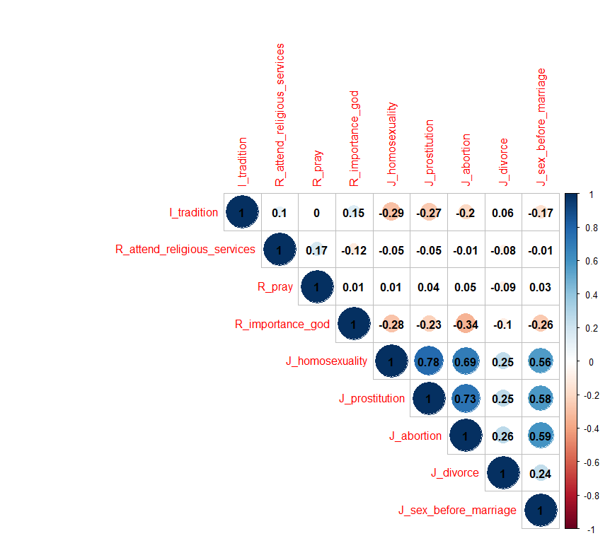

Figure 2: Correlation matrix of variables from Pakistan

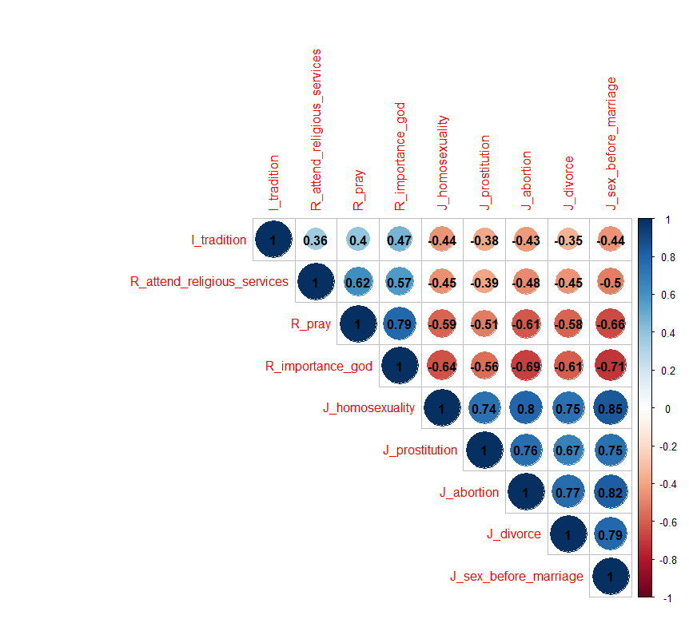

Figure 3: Correlation matrix of the variables from both Australia and Pakistan

**Section 5.2: System of equations**

There will 10 equations since there are 10 endogenous variables in the model.

Measurement model:

1. J_homosexuality = λ1* η2 + ε1
2. J_prostitution = λ2* η2 + ε2
3. J_abortion = λ3* η2 + ε3
4. J_divorce = λ4* η2 + ε4
5. J_sex_before_marriage = λ5* η2 + ε5
6. R_attend_religious_services = λ6* η1 + ε6
7. R_pray = λ7* η1 + ε7
8. R_imporatnce_god = λ8* η1 + ε8

Structural Model:

1. η1 = γ11* ξ + ζ1
2. η2 = γ21* ξ + β21* η1 + ζ2

**Section 6.1:**

6.1.1. Equations used in the programming for the evaluation

J_social_taboos=~J_homosexuality+J_prostitution+J_abortion+J_divorce+J_sex_before_marriage

I_religious_values =~ R_attend_religious_services+R_pray+R_importance_god

Direct effect: J_social_taboos ~ c*I_tradition

Mediator: I_religious_values ~ a*I_tradition & J_social_taboos ~ b*I_religious_values

Indirect effect: ab := a*b

Total effect: total := c + (a*b)'

6.1.2. Standardized Residual Variances of the indicator variables

|  |  |  |
| --- | --- | --- |
| Variables | Residuals | Std..Residuals |
| J_homosexuality | 2.545 | 0.194 |
| J_prostitution | 2.485 | 0.340 |
| J_abortion | 1.931 | 0.197 |
| J_divorce | 3.311 | 0.291 |
| J_sex_before_marriage | 1.772 | 0.127 |
| R_attend_religious_services | 2.362 | **0.564** |
| R_pray | 1.900 | 0.238 |
| R_importance_god | 2.138 | 0.182 |

Table 2: Standardized residual variances of the indicator variables

6.1.4. Modified Model

The equations for the model are as follows:

J_social_taboos=~J_homosexuality+J_prostitution+J_abortion+J_divorce+J_sex_before_marriage

I_religious_values =~ R_attend_religious_services+R_pray+R_importance_god

J_social_taboos ~ I_tradition

I_religious_values ~ I_tradition

J_social_taboos ~ I_religious_values

R_attend_religious_services ~~ R_pray

R_attend_religious_services ~~ R_importance_god

J_abortion ~~ J_sex_before_marriage

J_prostitution ~~ J_abortion

Standardized Factor Loadings of the modified model:

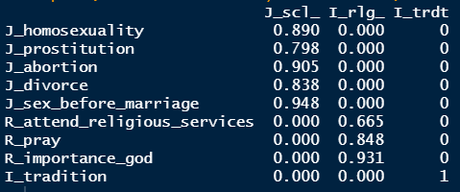

Fit Measures for the modified model:

|  |  |  |  |  |  |  |
| --- | --- | --- | --- | --- | --- | --- |
| Chi-sq | df | p-value | SRMR | CFI | TLI | RMSEA |
| 150.915 | 21 | 0.000 | 0.016 | 0.991 | 0.985 | 0.055 |

**Appendix B**

**R Code:**

#----------------------------STRUCTURAL EQUATION MODELS---------------------------------

remove(list = ls())

attach(wvs)

names(wvs)

## Creation of the dataframe

wvs_data <- wvs %>% select(V_tradition,

#indicators for importance of religion

R_attend_religious_services, R_pray, R_importance_God,

#indicators of justification of social taboos

J_homosexuality, J_prostitution, J_abortion, J_divorce, J_sex_before_marriage,

#Country

country)

wvs_df <- as.data.frame(wvs_data)

colnames(wvs_df) <- c("I_tradition", "R_attend_religious_services", "R_pray", "R_importance_god",

"J_homosexuality", "J_prostitution", "J_abortion", "J_divorce",

"J_sex_before_marriage", "country")

table_1 <- subset(wvs_df, country == "Australia")

table_aus <- table_1[-10]

table_2 <- subset(wvs_df, country == "Pakistan")

table_pak <- table_2[-10]

wvs_coded <- rbind(table_1,table_2)

sem_data <- rbind(table_aus, table_pak)

## Exploration

descriptive_sem_data <- as.data.frame(psych::describe(sem_data))

descriptive_sem_data <- dplyr::select(descriptive_sem_data, n, mean, sd, median, min,

max, skew, kurtosis)

descriptive_sem_data

# Covariance matrix of the variables

(cov_sem_data <- cov(sem_data))

(cov_table_aus <- cov(table_aus))

(cov_table_pak <- cov(table_pak))

# Plotting cov matrix using corrplot

(cor_sem_data <- cov2cor(cov_sem_data))

(cor_table_aus <- cov2cor(cov_table_aus))

(cor_table_pak <- cov2cor(cov_table_pak))

corrplot::corrplot(cor_sem_data,

is.corr = TRUE,

method = "circle",

type = "upper",

addCoef.col = "black")

corrplot::corrplot(cor_table_aus,

is.corr = TRUE,

method = "circle",

type = "upper",

addCoef.col = "black")

corrplot::corrplot(cor_table_pak,

is.corr = TRUE,

method = "circle",

type = "upper",

addCoef.col = "black")

## Checking the direct and indirect effect of I_tradition and I_religious_values on J_social_taboos

# using Mediation model

effects_model <- '## latent factors ##

J_social_taboos =~ J_homosexuality+J_prostitution+J_abortion+J_divorce+J_sex_before_marriage

I_religious_values =~ R_attend_religious_services+R_pray+R_importance_god

## Direct effect ##

J_social_taboos ~ c*I_tradition

## Mediator ##

I_religious_values ~ a*I_tradition

J_social_taboos ~ b*I_religious_values

## Indirect effect ##

ab := a*b

## Total effect ##

total := c + (a*b)'

fit_effects_model <- cfa(effects_model, data = sem_data)

summary(fit_effects_model, fit.measures = TRUE, standardized = TRUE)

# Checking the residuals (Difference between observed and implied covariance matrix)

residuals(fit_effects_model)

# Checking the fit measures

fitmeasures(fit_effects_model)

# Checking the parameter estimates with CI

parameterEstimates(fit_effects_model)

# Checking the standardized factor loadings

inspect(fit_effects_model, what = "std")$lambda

# looking at residual variances.

theta <- round(inspect(fit_effects_model,"est")$theta,3)

theta.std <- round(inspect(fit_effects_model,"std")$theta,3)

r2 <- round(inspect(fit_effects_model,"r2"),3)

r2

data.frame(row.names = c(),

Variables=colnames(theta),

"Residuals"=diag(theta),

"Std. Residuals"=diag(theta.std))

inspect(fit_effects_model, "r2")

# Global fit measures

fitMeasures(fit_effects_model, c("chisq", "df", "pvalue", "srmr", "cfi", "tli","rmsea"), output = "matrix")

# Modification fit indices

modificationindices(fit_effects_model)

# Local fit measures: modification indices

mi <- inspect(fit_effects_model,"mi")

mi.sorted <- mi[order(-mi$mi),]

mi.sorted[1:5,]

# Modifying the model

model_modified <- '## measurement part ##

J_social_taboos =~ J_homosexuality+J_prostitution+J_abortion+J_divorce+J_sex_before_marriage

I_religious_values =~ R_attend_religious_services+R_pray+R_importance_god

## Structural part ##

J_social_taboos ~ I_religious_values + I_tradition

I_religious_values ~ I_tradition

## Modification ##

R_attend_religious_services ~~ R_pray

R_attend_religious_services ~~ R_importance_god

J_abortion ~~ J_sex_before_marriage

J_prostitution ~~ J_abortion'

fit_model_modified <- cfa(model_modified, data = sem_data)

summary(fit_model_modified, fit.measures = T, standardized = T)

# Global fit measures

fitMeasures(fit_model_modified, c("chisq", "df", "pvalue", "srmr", "cfi", "tli","rmsea"), output = "matrix")

# Checking the standardized factor loadings

inspect(fit_model_modified, what = "std")$lambda

## Multigroup modelling

wvs_coded$country <- factor(wvs_coded$country, levels = c("Australia", "Pakistan"), labels = c("Australia","Pakistan"))

str(wvs_coded)

# Configural invariance

fit_configural <- cfa(effects_model, data = wvs_coded, group = "country")

summary(fit_configural, fit.measures = TRUE, standardized = TRUE)

# Global fit measures

fitMeasures(fit_configural, c("chisq", "df", "pvalue", "srmr", "cfi", "tli","rmsea"), output = "matrix")

# Metric invariance

fit_metric <- cfa(effects_model, data = wvs_coded, group = "country", group.equal = c("loadings"))

summary(fit_metric, fit.measures = T, standardized = T)

# Global fit measures

fitMeasures(fit_metric, c("chisq", "df", "pvalue", "srmr", "cfi", "tli","rmsea"), output = "matrix")

# Function to extract fit indices

model_fit <- function(lavobject) {

vars <- c("df", "cfi", "tli", "rmsea", "rmsea.ci.lower", "rmsea.ci.upper", "rmsea.pvalue", "srmr")

return(fitmeasures(lavobject)[vars] %>% data.frame() %>% round(2) %>% t())

}

table_fit <-

list(model_fit(fit_configural),

model_fit(fit_metric)) %>%

reduce(rbind)

rownames(table_fit) <- c("Configural", "Metric")

table_fit

# compare the nested model using the anova function

table_anova <- list(anova(fit_configural, fit_metric),

anova(fit_metric)) %>%

reduce(rbind) %>%

.[-c(3, 5, 7),]

table_anova

**References:**

1. Thoresen CE. Spirituality, health, and science: The coming revival? In: Roth-Roemer S, Kurpius SR, editors. *The emerging role of counseling psychology in health care.* New York: W. W. Norton; 1998. pp. 409–431.
2. Mariam Rawan Abdulla (2018) *Culture, Religion, and Freedom of Religion or Belief*, The Review of Faith & International Affairs, 16:4, 102-115.
3. Chaim Fershtman, Uri Gneezy, and Moshe Hoffman (2011). *Taboos and Identity: Considering the Unthinkable. pp. 139-143.* American Economic Journal, 139–164.
4. World Population Review.

[Online] Available: https://worldpopulationreview.com/en/country-rankings/least-religious-countries

1. World Value Survey

[Online] Available: <https://www.worldvaluessurvey.org/WVSContents.jsp>

1. Kline, R.B. (2016). *Principles and practices of structural equation modeling.* Guilford: New York, Chapter 1 (Coming of Age).